# INTRODUCTION

## RAILWAY GATE CONTROL SYSTEM

Railways have provided railway gates for safety at the level crossings. These gates are closed for road traffic when a train is expected to arrive on the track. The gates are opened for road users once the train levels the crossing. Level crossing in India can be divided into two categories manual and un-manual.

Manual level crossings are those, which are guarded by a gatemen as employee of Railways. The gate inhibits the Road traffic by closing the gate on the receipt of approaching train information from control cabin through a telephone line. Also in this type of system, the engine driver obtains a green signal only when the railway gate is closed. Most of the level crossings nearer to Railway station or in rural areas are manual. Un-Manual level crossings are places, which are un-guarded. Therefore, a slight amount of negligence on the part of road users leads to accidents at such places. Most of the crossings in remote areas or villages with low population density are of un-manual type. It may be worth mentioning here that most of train accidents leading to loss of property and life occurred at un-manual level crossings. However, of course warning all level crossings in the vast network of Indian Railways is practically impossible. Accidents did occur even at manual level crossings due to the errors committed by gateman. We have given an idea in overcoming this problem of accidents at Railway gates. The advantage of this system is that human error is eliminated. The problem of accident risks at un-manual level crossings is solved. Financial burden on railways is reduced due to reduction of manpower.

## DIFFERENT METHODS OF IMPLEMENTING THE PROJECT

We can use other methods also for implementing the same project. These methods are:

* By using Weight Sensors, in this the weight sensors senses the weight of the train and with that intimates the arrival of the train.
* By using Global Positioning System
* By radio wave communication, this can be done by either by Amplitude modulation (A.M.) or Frequency Modulation (F.M.). The more desirable way of communication is FM because FM is less susceptible to outside interference and noise (e.g., thunderstorms, nearby machinery) than is AM. Such noise generally affects the amplitude of a radio wave but not its frequency, so an FM signal remains virtually unchanged.
* Using GSM Modem And Microcontroller, in this the basic concept of the project is that the railway crossing gate that uses the DC motor to move up and down is associated with a microcontroller unit circuit. This circuit uses a GSM Modem. We know that the GSM Modem receives or sends the messages. So, some AT commands (Read by microcontroller) are sent to the microcontroller through sms from on GSM Modem to another by the station master. In this project we are controlling the DC motor that controls Railway Crossing Gate. The project works in two modes. The first one is scheduled mode and second is manual mode. By scheduled mode the AT commands are sent at a scheduled time from the GSM modem setup at the station master side and receives by the microcontroller circuit and it returns the response message that the crossing gate has opened or closed and if the time of arriving the train varies (late or soon) then the station master manually sends the AT commands in a message to the microcontroller.

Here we are using IR sensors for the same purpose.

# AUTOMATIC RAILWAY GATE CONTROL SYSTEM

## PROJECT DESCRIPTION

The place where track and highway/road intersects each other at the same level is known as “level crossing”. Railways being the cheapest mode of transportation are preferred over all the other means. When we go through the daily newspapers we come across many railway accidents occurring at unmanned railway crossings. At present scenario, in level crossings, the railway gate is operated normally by a gatekeeper after receiving the information about the train's arrival. When a train starts to leave a station, station master of the particular station delivers the information to the nearby gate. This is mainly due to the carelessness in manual operations or lack of workers. We, in this paper have come up with a solution for the same. Using simple electronic components we have tried to automate the control of railway gates. As a train approaches the railway crossing from either side, the sensors placed at a certain distance from the gate detects the approaching train and accordingly controls the operation of the gate. Also an indicator light and buzzer are provided to alert the people about the approaching train.

[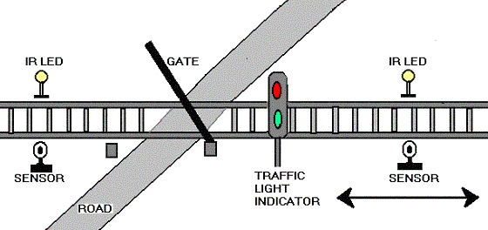](http://electrofriends.com/wp-content/uploads/2008/11/crossing.jpg)

## ACCIDENT AVOIDENCE DETAILS

When the train arrives in a particular direction the transmitter IR senses and generates appropriate signal, then at the same time the receiver IR receives the signal and generates an interrupt. When the interrupt is generated the motor rotates in clockwise direction. When the interrupt ends the motor rotates in anti clock wise direction.

# PROJECT IMPLEMENTATION

## COMPONENTS USED

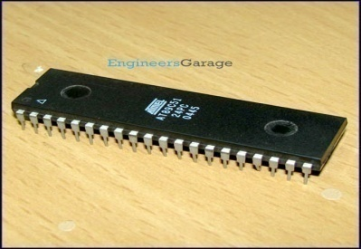 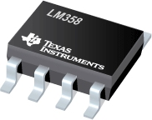 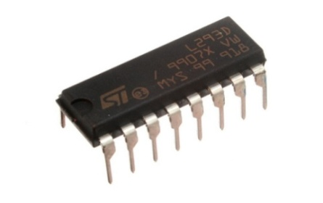

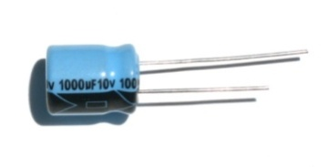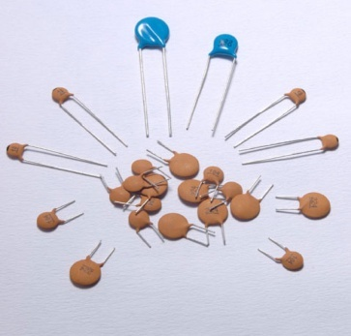 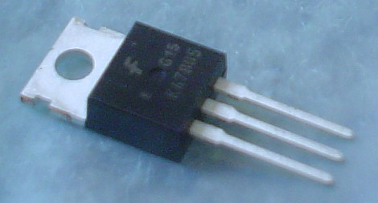

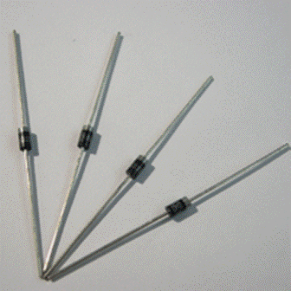 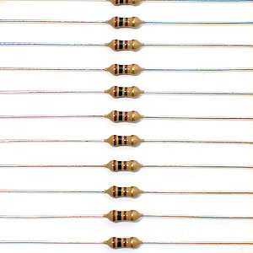 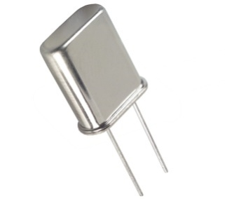

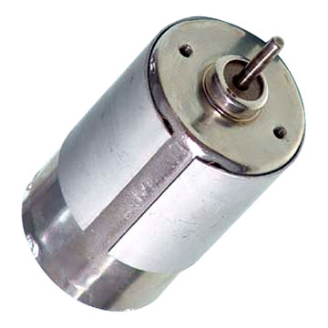 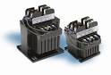

## BUDGET

**S.NO COMPONENTS QUANTIY COST**

1 AT89C51 1 Rs 80/-

2 L293D 1 Rs 120/-

3 LM358 1 Rs 30/-

4 DC MOTOR 1 Rs 200/-

5 REGULATOR (7805) 1 Rs 15/-

6 TRANSFORMER 1 Rs 30/-

7 MAIN LEAD 1 Rs 15/-

8 PCB HOLE SHEET 1 Rs 20/-

9 CRYSTAL OSCILLATOR 1 Rs 30/-

10 IR TRANSMITTER 1 Rs 2/-

11 IR RECEIVER 1 Rs 2/-

12 LED 2 Rs 3/-

13 RESISTOR 4 Rs 5/-

14 CAPACITOR 3 Rs 30/-

15 JUMPING WIRES 1(ROLL) Rs 15/-

16 DIODES 5 Rs 20/-

17 MISCELLANEOUS Rs 200/-

**TOTAL COST= Rs 817/-**

## FLOW CHART



## BLOCK DIAGRAM

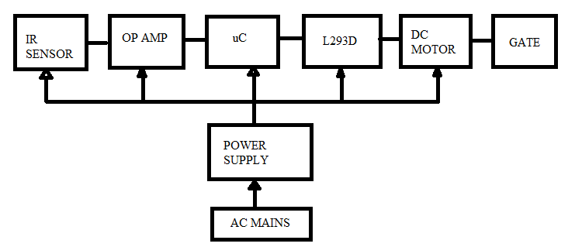

## BLOCK DIAGRAM DESCRIPTION

* **Power Supply**

It is used to provide power to all the components.

* **IR Sensors**

It is used for transmitting and receiving signals. It has two parts:

* Transmitter unit: It consists of infrared led and a resistor (470ohm).



* Receiver unit: It consists of a photodiode and a resistor (4.7Kohm).



* **Operational Amplifier**

It is used for comparing the signals and accordingly generates output for microcontroller.

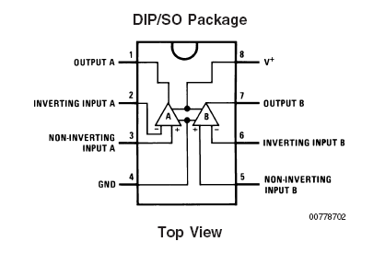

* **L293D (Motor Driver)**

It is used to drive stepper motor.

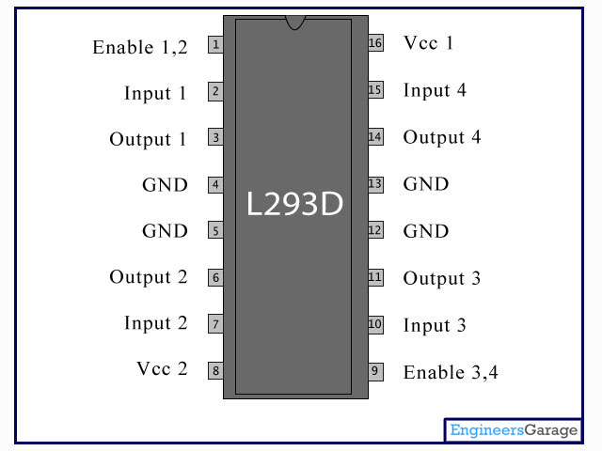

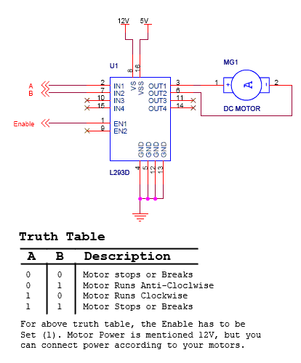

* **Microcontroller**

It controls the circuit according to the instructions given to it.

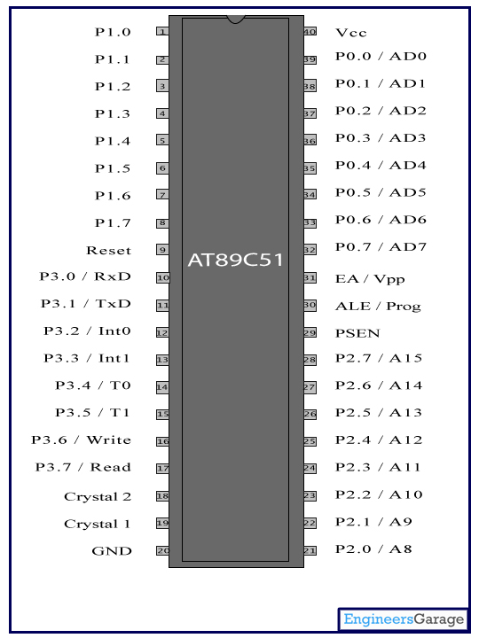

* **DC Motor**

It is used to open and close the gate automatically.

## CIRCUIT DIAGRAM

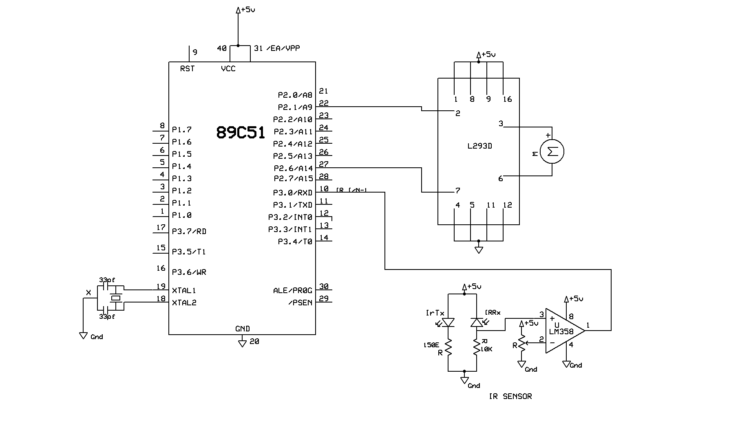

# WORKING

## WORKING OF PROJECT

Present project is designed using 8051 microcontroller to avoid railway accidents happening at unattended railway gates, if implemented in spirit. This project utilizes two powerful IR transmitters and two receivers; one pair of transmitter and receiver is fixed at upside (from where the train comes) at a level higher than a human being in exact alignment and similarly the other pair is fixed at down side of the train direction. Sensor activation time is so adjusted by calculating the time taken at a certain speed to cross at least one compartment of standard minimum size of the Indian railway. We call the sensor along the train direction as ‘foreside sensor’ and the other as ‘aft side sensor’. When foreside receiver gets activated, the gate motor is turned on in one direction and the gate is closed and stays closed until the train crosses the gate and reaches aft side sensors. When aft side receiver gets activated motor turns in opposite direction and gate opens and motor stops. Buzzer will immediately sound at the fore side receiver activation and gate will close after few seconds, so giving time to drivers to clear gate area in order to avoid trapping between the gates and stop sound after the train has crossed.

## WORKING OF CIRCUIT

AC mains supply is given to the circuit, it is then step down by the centre tapped transformer of rating 909. This ac voltage is then applied to a full wave bridge rectifier formed by four diodes (IN4007) this rectifier converts ac voltage to dc voltage and removes the ripples. This voltage is then passed through the electrolytic capacitors (100uF) for filtration and then voltage regulator (7805) regulates it to 5V dc.

This supply voltage is given to the microcontroller, op amp and motor driver IC L293D.

Signal generated by IR sensor is sent to op amp which compares the voltage level and accordingly send those signals to microcontroller (AT 89C51). Microcontroller then generates the interrupt which is given to motor driver IC L293D, which will drive the DC motor.

## PROJECT PHOTOGRAPH

### PROJECT IN IDLE CONDITION

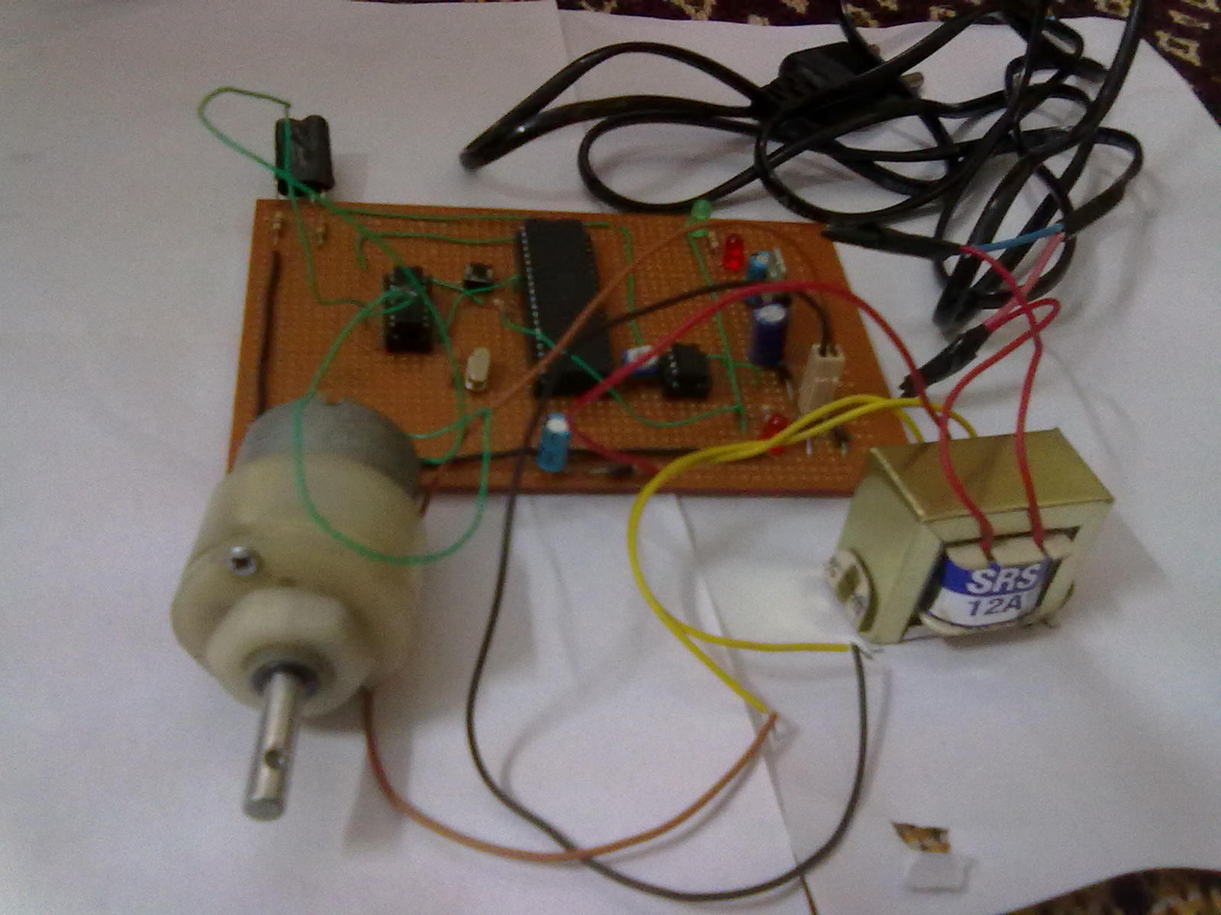

### PROJECT IN WORKING CONDITION

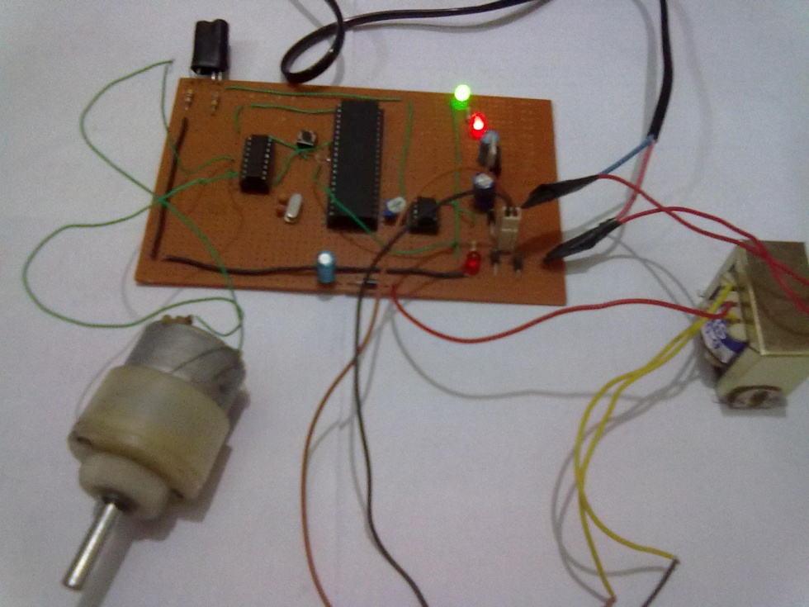

# RESULT

The present existing system is manually and human controlled system, once the train leaves the station, the stationmaster informs the gatekeeper about the arrival of the train by telephone. Gatekeeper on receiving information closes the gate depending on the timing at which the train arrives. Hence, if the train is late due to certain reasons, then gate remain closed for a long time causing traffic near the gates. By employing the automatic railway gate control at the level crossing, the time for which it is closed is less compared to the manually operated gates and also reduces the human labor. This type of gates can be employed in an unmanned level crossing where the chances of accidents are higher and reliable operation is required. Since, the operation is automatic the error due to manual operation is prevented. And implementing the work, railway system can be centralized which can control the train collision accidents.

## ADVANTAGES

* Accident avoidance.
* Human Resource.
* Safety and quality of services.

## DISADVANTAGES

* Use of automatic system will be expensive than gate operated by gatekeeper.

## APPLICATIONS

* In real time transport system.

# CONCLUSION AND FUTURE SCOPE

## CONCLUSION

With the help of “AUTOMATIC RAILWAY GATE CONTROL SYSTEM” the accidents can be avoided at places where there is no person managing the railway crossing gates. By this the control system of railway gate can be managed using the microcontroller. When train arrives at the sensing point alarm is triggered at the railway crossing point so that the people get intimation that gate is going to be closed. Then the control system activates and closes the gate on either side of the track. Once the train crosses the other end control system automatically lifts the gate. For mechanical operation of the gates dc motors are employed. Also, LEDs and buzzers are used to intimate the people about the arrival of the train. The automation of the railways is such that it save energy, provide full safety from the loss of man and material. So this type of system can be applied in any railways. This will be very helpful in the development of any country both financially and technically.

## FUTURE SCOPE

Here, we have implemented the hardware circuit successfully automatically opening and closing of the gate using sensors. This project can be extended for the communication between the engine driver and officials when the train encounters a technical fault. Based on this we can also install train protection system throughout the railway track, so that train accidents can be avoided.

# REFERENCES

* Automated unmanned railway level crossing system: by J BANUCHANDAR
* Automation of railway gate controller using microcontroller: International Journal of Engineering Research and Technology
* Automatic Railway Gate Control & Track Switching<< India Engineers
* Automatic Railway Gate Controller using GSM Modem & Microcontroller, Engineering projects
* Engineering E Books/ Engineering papers: Automatic Railway Gate Control System Project
* http://www.engineersgarage.com/sites/defaults/files/AT89C51
* http://www.engineersgarage.com/sites/defaults/files/LM358
* http://www.engineersgarage.com/sites/defaults/files/L293D
* http://www.engineersgarage.com/sites/defaults/files/DC-motor